GPS Alignment Statements:

The Government Policy Statement on Land Transport 2024 (GPS) sets out the central Government’s expectations, and references objectives for road safety and efficiency. The following statements outline how the proposed speed limit changes align with the GPS.
Curran Road | The proposal to increase the speed limit on Curran Road (Dunns Road to Otatara Road) is aligned with the GPS by enabling people and freight to move around efficiently, quickly and safely, supporting economic growth and productivity. The form and function of Curran Road supports the speed limit being increased from 60km/h to 80km/h.
Retreat Road and Bainfield Road | The proposal to decrease the speed limits on Retreat Road (Bainfield Road to McIvor Road), and Bainfield Road (east of Queens Drive to east of Inverurie Drive) is aligned with the GPS by reducing the estimated number and severity of crashes. The proposal reflects existing land use in the area and reinforces expected safe road user behaviour. The form and function of Retreat Road and Bainfield Road supports the speed limit being decreased from 60km/h to 50km/h.
McQuarrie Street | The proposal to decrease the speed limit on McQuarrie Street (Chesney Street to Rockdale Road) is aligned with the GPS by reducing the estimated number and severity of crashes. The proposal reflects existing land use in the area and reinforces expected safe road user behaviour. The form and function of Curran Road supports the speed limit being decreased from 80km/h to 60km/h.

Regulatory Statements:

CURRAN ROAD
Role and function | Curran Road connects Stead Street to Otatara Road. Curran Road is classified as a Rural Connector under the ONF. Adjoining land use is predominantly rural development. The posted speed limit for Curran Road is 60km/h.
Road use characteristics | Under Schedule 3 of the Setting of Speed Limits 2024, Table 2 Rural Street Classifications, Curran Road is classified as Rural. This is defined as roads that primarily provide access to rural land for people who live there and support the land-use activity being undertaken. The Speed Limit for Rural Roads under the Rule is between 80 – 100 km/h.
Speed limit change versus speed management intervention. | While Curran Road is classified as a Rural Connector, the road is unlikely to attract significant funding for improvements in the future. A change in speed limit is therefore considered appropriate.
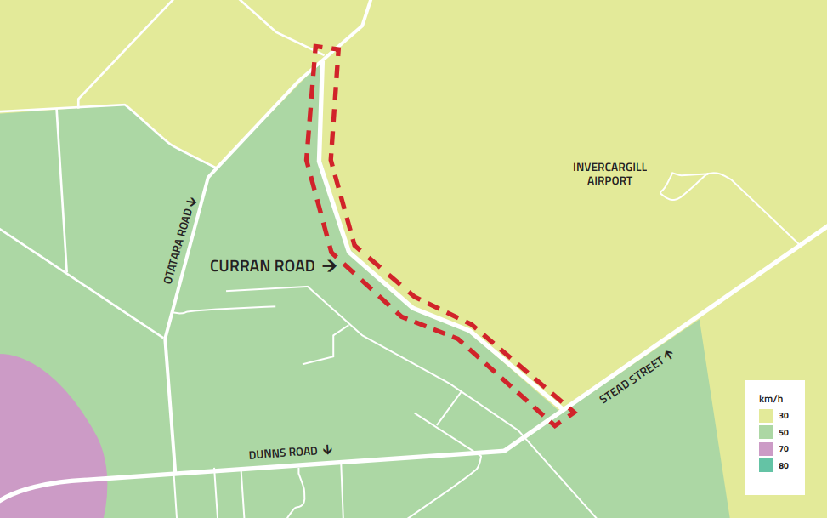

RETREAT ROAD
Role and function | Retreat Road connects McIvor Road and Bainfield Road. It is classified as a peri-urban road south of Inverurie Drive, and a rural connector north of Inverurie Drive, under the ONF. The posted speed limit for Retreat Road is 60km/h.  Adjoining land use is predominantly residential. There are residential dwellings on both sides of Retreat Road. The development is predominantly lifestyle blocks but is density increases it approaches the Bainfield Road intersection.
Road use characteristics | Under Schedule 3 of the Setting of Speed Limits 2024, Table 2 Rural Street Classifications, Retreat Road is classified as a peri-urban road. These are defined as roads that primarily provide access from residential property on the urban fringe or in a rural residential area, where the predominant adjacent land use is residential, but usually at lower density than in urban residential locations. The Speed Limit for peri-urban roads under the Rule is between 50 – 80 km/h.
Speed limit change versus speed management intervention. | A change in speed limit is considered to be appropriate for Retreat Road as the road is unlikely to attract significant capital investment in the future.
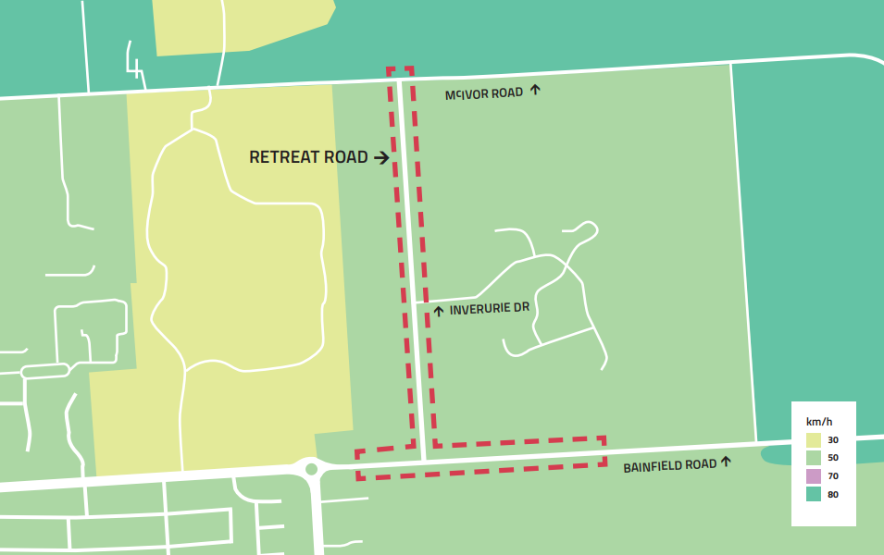

BAINFIELD ROAD
Role and function | Bainfield Road runs east west connecting SH6 (North Road) to Mill Road North. It is classified as a peri-urban road west of Retreat Road, and a rural connector east of Retreat Road, under the ONF. The posted speed limit for the section of Retreat Road being reviewed is 60km/h.  Adjoining land use on the section of Bainfield Road being reviewed is predominantly residential to the west of Inverurie Drive, decreasing in density to rural-residential to the east. The posted speed limit for the section of Bainfield Road being reviewed is 60km/h, changing to 80km/h east of Inverurie Drive.
Road use characteristics | Under Schedule 3 of the Setting of Speed Limits 2024, Table 2 Rural Street Classifications, Bainfield Road is classified as a peri-urban road. These are defined as roads that primarily provide access from residential property on the urban fringe or in a rural residential area, where the predominant adjacent land use is residential, but usually at lower density than in urban residential locations. The Speed Limit for peri-urban roads under the Rule is between 50 – 80 km/h.
Speed limit change versus speed management intervention. | A change in speed limit is considered to be appropriate for Retreat Road as the road is unlikely to attract significant capital investment in the future.

MCQUARRIE STREET
Role and function | McQuarrie Street runs east-west, connecting Brown Street to Rockdale Road. The posted speed limit for the section of McQuarrie Street being reviewed is 60km/h.  McQuarrie Street is classified as a peri-urban road under the ONF. Adjoining land use is predominantly rural-residential between Chesney Street and Rockdale Road.
Road use characteristics | Under Schedule 3 of the Setting of Speed Limits 2024, Table 2 Rural Street Classifications, McQuarrie Street is classified as a peri-urban road. These are defined as roads that primarily provide access from residential property on the urban fringe or in a rural residential area, where the predominant adjacent land use is residential, but usually at lower density than in urban residential locations. The Speed Limit for peri-urban roads under the Rule is between 50 – 80 km/h.
Speed limit change versus speed management intervention. | A change in speed limit is considered to be appropriate for McQuarrie Street as the road is unlikely to attract significant capital investment in the future.
